Developing an Interactive Upper Limb Training Device for Arm Stretching and Reaching Exercise

Submitted by Zhou Yuqing

Soochow University

School of Electronic and Information Engineering

The final year project work was carried out under the 3+1+1 Educational Framework at the National University of Singapore (Suzhou) Research Institute

**May 2023**

# ABSTRACT

Cerebral palsy is a disease that affects human motor ability, balance, and posture, especially in children. To restore muscle function and improve cognitive abilities, children with cerebral palsy often require regular and repetitive exercises. However, the reality is that many patients are unable to receive rehabilitation treatment in healthcare institutions due to medical costs and logistical limitations, and traditional rehabilitation training can be boring and unable to record detailed patient recovery information.

To address this issue, this project proposes a portable, cost-effective, and user-friendly human-computer interactive spherical upper limb rehabilitation device. The device includes a portable wireless spherical rehabilitation device and an interactive computer game that can be used independently by children at home without the assistance of professional medical personnel. In this project, I am mainly responsible for user surveys, hardware circuit design and production, 3D modeling and printing, programming of the embedded chip ESP32ROOM, programming of the MPU6050 sensor, human-computer interaction debugging, and wireless storage of motion data on the Alibaba Cloud platform. The programming of the embedded chip ESP32ROOM involves the use of classic Bluetooth and Wi-Fi. The programming of MPU6050 involves the use of I2C bus and Euler angle calculations. The data storage on the Alibaba Cloud platform involves the use of MQTT IoT protocol.

In the end, we successfully designed an upper limb rehabilitation device that can be applied in practice. The device has two complementary rehabilitation games that use audiovisual feedback in the games to guide patients in active rehabilitation training. The use of the Alibaba Cloud platform allows for the recording of some patient data during the rehabilitation training process. Additionally, this project has successfully entered the finals of the Yangtze River Delta Innovation Cup, and we hope to achieve good results in the finals and apply for a utility model patent.

# ACKNOWLEDGMENTS

I would like to express my heartfelt gratitude to Professor Liang Yung Chii from the Department of Electrical and Computer Engineering at the National University of Singapore, Professor Sun Jie from Xi'an Jiaotong-Liverpool University, Professor Huang Xu from the Department of Communication Engineering at Soochow University, and Professor Bu Qinglei from the Department of Intelligent Mechatronics at Xi'an Jiaotong-Liverpool University for their meticulous guidance. Your professional expertise and profound academic knowledge have greatly benefited me, and your guidance and advice during my project have played a crucial role in driving my research forward.

I would also like to thank Xi'an Jiaotong-Liverpool University for providing guidance on 3D printing technology, which has been instrumental in supporting my research. The financial and technical support from the Medical Engineering Cross Research Institute in the Yangtze River Delta region has also been invaluable in ensuring the smooth progress of my research. Additionally, I am grateful for the companionship and support of my friends, as well as the collaborative efforts of my colleagues in the research institute. I would like to express my appreciation to my team member, Niu Qisong, for his suggestions and efforts in game design.

Lastly, I cherish the time spent on this project as a valuable opportunity for learning, growth, and accumulation of precious experience and knowledge. Once again, I express my sincere thanks for your support and guidance, and I am committed to continuing my efforts in contributing to academic research and scientific advancement.

# CONTENTS

ABSTRACT i

ACKNOWLEDGMENTS ii

LIST OF FIGURES v

LIST OF TABLES vii

LIST OF SYMBOLS AND ABBREVIATIONS viii

CHAPTER 1 Introduction 1

* 1. Background 1
  2. Literature Review 2
  3. Main Research Content 4
  4. Organization of The Thesis 5

CHAPTER 2 User Study 6

* 1. Hospital Visit 6
  2. Preliminary Survey 7
  3. Design requirements 8

CHAPTER 3 Overview of The Hardware Design 9

* 1. System Design Proposal 9
  2. Hardware Structure and Analysis 10
     1. Component Selection 10
     2. Hardware Connection 16
     3. Modeling 17

CHAPTER 4 Overview of The Software Design 21

* 1. Overall Software Design 21
  2. Data Collection Based on ESP32 22
  3. Communication between microcontroller and PC 24
  4. Game Design and Implementation Based on Unity Platform 25
  5. Data Processing Based on Cloud Platform 26

CHAPTER 5 Testing 28

* 1. Device Function Test 28
  2. Main Problems and Solutions 30

CHAPTER 6 Results 32

CHAPTER 7 Conclusion and Future Work 35

* 1. User Feedback 35
  2. Conclusion 35
  3. Future Work 36
  4. Personal Contribution 36

REFERENCES 37

# LIST OF FIGURES

Figure 1 : Cerebral Palsy Prevalence Among 8-Year-Old Children Page 1 Figure 2 : Market size of medical devices in China, 2016-2030E Page 2 Figure 3 : Overview of the proposed wrist rehabilitation system Page 3 Figure 4 : Productions from Tyromotion Page 4

Figure 5 : Hospital on-site inspection Page 6

Figure 6 : Questionaire of the preliminary survey Page 7

Figure 7 : Survey Results Page 8

Figure 8 : Prototype system Page 9

Figure 9 : Hardware Component Page 10

Figure 10 : Hardware development process Page 10

Figure 11 : MPU6050 Page 12

Figure 12 : ESP32 ROOM Page 14

Figure 13 : TP4056 charging module Page 16

Figure 14 : Overall hardware connection Page 17

Figure 15 : Model Concept Page 17

Figure 16 : Model Iterations Page 18

Figure 17 : Physical model of the final version Page 20

Figure 18 : Software Structure Page 21

Figure 19 : Software Structure Page 22

Figure 20 : Flowchat of Data Collection Based on ESP32 Page 22

Figure 21 : Flowchat of BlueTooth Usage Page 24

Figure 22 : Game concept Page 25

Figure 23 : Game design process Page 25

Figure 24 : Cloud platform connection process Page 27

Figure 25 : Alibaba Cloud platform device certificate Page 27

Figure 26 : Bluetooth connection Page 28

Figure 27 : Charging port Page 29

Figure 28 : Alibaba Cloud platform connection Page 29

Figure 29 : Unity connection and control Page 30

Figure 30 : Airplane flying game Page 32

Figure 31 : Drawing game Page 33

Figure 32 : Transmission and recording function on Cloud platform Page 33 Figure 33 : Date record and update Page 34

Figure 34 : The second hospital visit Page 35

# LIST OF TABLES

|  |  |  |
| --- | --- | --- |
| Table 1 | IMU selection | Page 11 |
| Table 2 | MCU selection | Page 13 |
| Table 3 | Wireless Transmission Module selection | Page 15 |
| Table 4 | Power Supply Schemes | Page 16 |
| Table 5 | Gyroscope configuration register | Page 22 |
| Table 6 | Accelerometer configuration register | Page 23 |
| Table 7 | Gyroscope sampling rate divider register | Page 23 |

# LIST OF SYMBOLS AND ABBREVIATIONS

*fsample*

Sampling frequency

*q*0,1,2,3

Unit quaternion

MCU Inertial Measuring Unit

IMU Microcontroller Unit

vi

**CHAPTER 1**

**Introduction**

## Background

Cerebral palsy is a disease that affects a person's ability to move, maintain balance, and posture. It is the most common motor disorder in childhood, with approximately 1.8 million children with cerebral palsy in China and an annual increase of 50,000 cases. The reported prevalence of cerebral palsy worldwide ranges from 0.154% to 0.40%, and the latest surveillance data in China shows an incidence rate of 2.48‰, highlighting the urgent need for prevention, treatment, and intervention for cerebral palsy.[1,2]

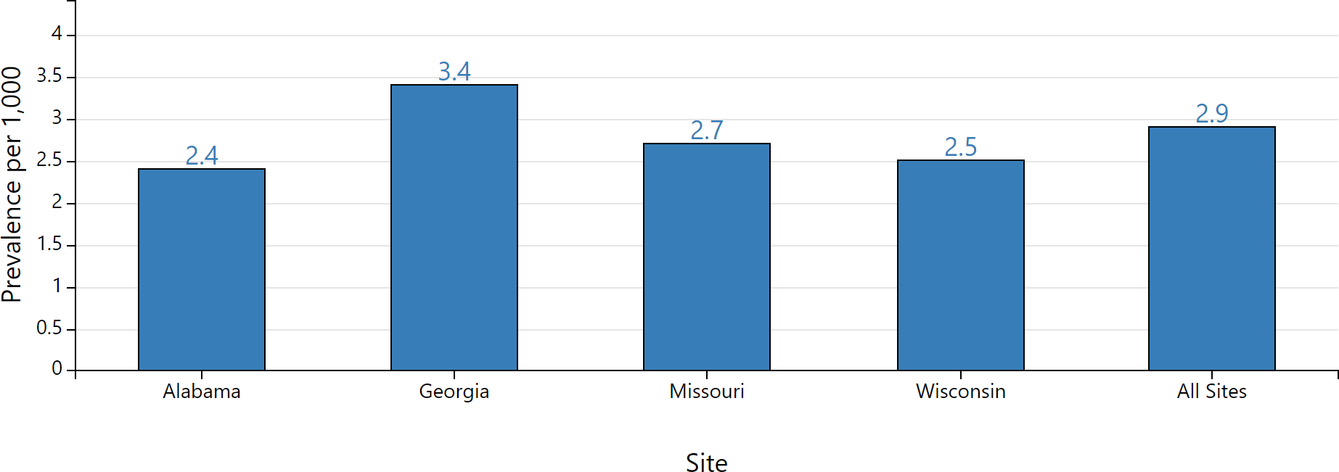

Figure 1 : Cerebral Palsy Prevalence Among 8-Year-Old Children [1]

Furthermore, the rehabilitation medical device industry market in China has been experiencing rapid growth. From 2016 to 2020, the market size of China's medical devices increased from 370 billion RMB to 729.7 billion RMB, with a compound annual growth rate of 18.5% during this period. In 2020, China's medical device market accounted for 23.2% of the global medical device market, and it is projected to reach 1,688.78 billion RMB by 2030. In the same year, rehabilitation assessment and training devices accounted for a significant market share of 89.3% among all rehabilitation devices. This indicates that portable rehabilitation training devices with assessment capabilities have a highly promising market outlook.[3,4]

Children with cerebral palsy need to undergo regular and intensive rehabilitation training to regain muscle strength. Reports have pointed out that using self-generated movement to practice real-life tasks and activities with high intensity, relying on experience-dependent

plasticity to set goals and stimulate spontaneous training is beneficial and enjoyable for

children. Passive movement interventions have poor or even ineffective effects on improving the function and movement of children with cerebral palsy, thus promoting rehabilitation devices that encourage active movement has broad application prospects [5,6,7].

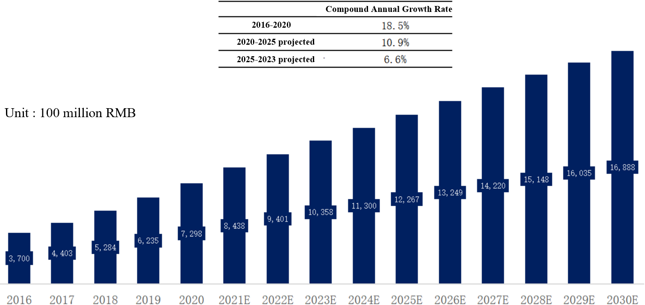

Figure 2 : Market size of medical devices in China, 2016-2030E [5]

Traditional upper limb rehabilitation devices include comprehensive occupational therapy (OT) workstations, sanding boards, and rollers. The comprehensive OT workstation integrates various rehabilitation toys to improve finger pointing ability, hand-eye coordination, and train upper limb coordination and cognitive ability in children with cerebral palsy. However, it is expensive and requires real-time guidance from medical personnel, and the cognitive level improvement for children is limited by the game content. Sanding boards and rollers specifically train certain indicators of upper limb rehabilitation, improving upper limb stability or balance and coordination ability, but the process is monotonous. Overall, traditional rehabilitation devices have flaws such as complex wearing, dependence on professional medical personnel, and passive performance of children. [8]

To address these issues, this study will develop a sensor-based human-computer interactive spherical upper limb rehabilitation device that allows unassisted three-dimensional shoulder, elbow, and wrist joint movements on one or both sides, guiding children to actively engage in rehabilitation through audio-visual feedback, and correcting children's movements with a vision-based human motion correction system, providing motion comparison, analysis, and evaluation.

## Literature Review

Extensive research has been conducted both domestically and internationally on upper limb

rehabilitation for children with cerebral palsy. The following is a list of representative research articles that are relevant to the topic of this study.

### A home-based wrist rehabilitation system

The system utilizes electronic and computer engineering technologies to design a portable device for wrist rehabilitation training at patients' homes. It includes a wrist motion capture sensor and an interactive virtual reality interface to provide real-time rehabilitation guidance and feedback. By using this system, patients can conduct rehabilitation training at home without frequent visits to medical institutions. [9]

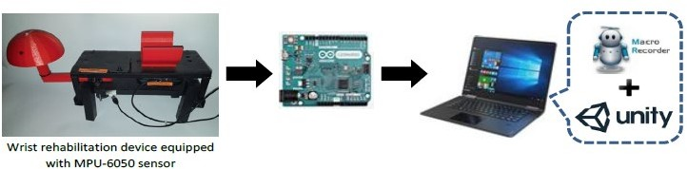

Figure 3 : Overview of the proposed wrist rehabilitation system [9]

The design is based on the Ariduno development board and the Unity platform, providing a design concept for interactive engagement with pediatric patients through computer games. The introduction of computer game elements creates an opportunity to attract children's attention. The design of a hemisphere-shaped physical rehabilitation device, which allows for muscle exercise in multiple directions, gives us inspiration . However, the existing system is bulky and not easily portable, as it can only be fixed in one place. Additionally, the game interface design is simple and dull, with only a few lines and a soccer pattern, which does not meet the requirement of attracting children's attention.

### Robotic and Sensor Technology for Upper Limb Rehabilitation

The design inspiration for this project is mainly derived from the products of Tyromotion, as mentioned in this literature. Tyromotion is an Austria company that specializes in the research and development, as well as production, of robotics and sensor technology for rehabilitation and sports therapy, catering to the needs of different patients and stages of rehabilitation. Tyromotion offers a wide array of commercial devices, including two robotic devices, AMADEO and DIEGO, and three sensor-based systems, PABLO, TYMO, and MYRO (Figure

4). The treatment modes range from passive movement to active-assistive, active, and resistive movements. In order to maximize patient engagement during the treatment process, the use of robots has transitioned from motor-driven assistance to sensor-based feedback systems. For upper limb rehabilitation, the two robotic devices and three sensor systems cover the needs of the entire upper limb and trunk, providing rehabilitation training based on injury and specific tasks.[10]

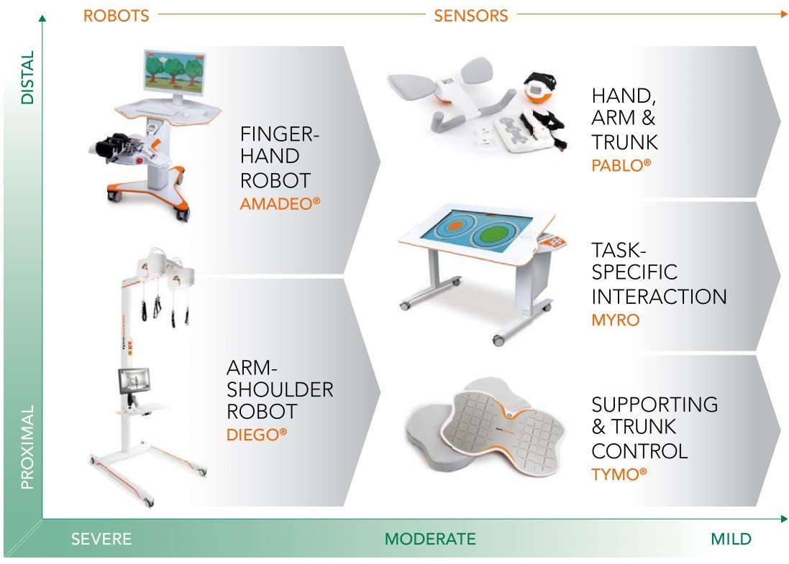

Figure 4 : Productions from Tyromotion [10]

However, there are also significant limitations to Tyromotion's devices. Firstly, the high cost is a major concern. Tyromotion's products are typically expensive, requiring substantial investment in equipment and software, as well as professional maintenance and management, which may increase the cost of rehabilitation treatment. Secondly, there is a complexity in the technology. Tyromotion's products require doctors and rehabilitation therapists to possess certain skills and training, placing high demands on the skills of the rehabilitation team and potentially increasing training and learning costs.

## Main Research Content

The aim of this study is to design a portable, cost-effective, and user-friendly human-computer interactive spherical upper limb rehabilitation device, which exercises the finger, wrist, and shoulder muscles including the flexor carpi ulnaris, superficial flexor digitorum, and brachioradialis of pediatric patients. The device provides visual, auditory, and tactile feedback to guide patients in achieving predefined rehabilitation goals, and generates health data reports

for cloud uploading.

## Organization of The Thesis

Chapter 2 of this paper presents the results of a user survey conducted before the start of the design. Chapters 3 provides an overview of the hardware design plan, as well as a detailed hardware selection and modeling process. Chapters 4 gives an overview of the software design. Chapter 5 presents the testing plan and process for this design. Chapter 6 shows the final implementation of this design. Chapter 7 introduces user feedback on the final design and provides a summary of the entire paper, along with future works and personal contribution.

## CHAPTER 2

**User Study**

## Hospital Visit

In order to better understand the current practices and methods of rehabilitation exercises for children with cerebral palsy, a field survey was conducted at Mingji Hospital in Suzhou, Jiangsu Province, prior to the formal implementation of this study. The survey included questions about the types of rehabilitation exercise programs used for children with cerebral palsy, exercise frequency and duration, equipment and tools used, involvement of healthcare professionals, and challenges faced in implementing rehabilitation exercise programs.

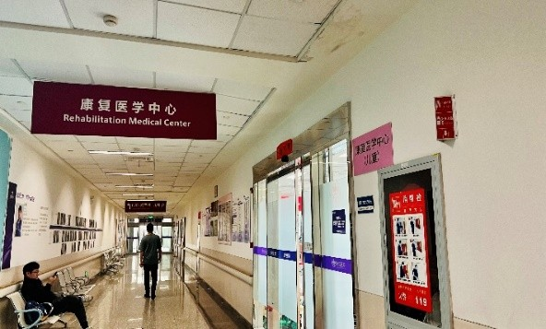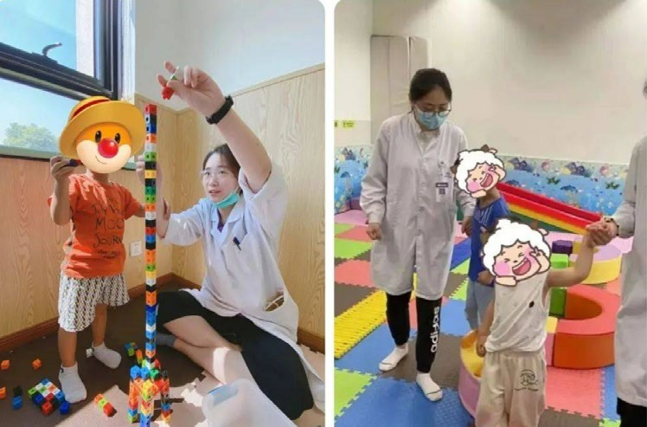

Figure 5 : Hospital on-site inspection

The results of the hospital survey showed that various rehabilitation exercise programs were used for children with cerebral palsy, including physical therapy, occupational therapy, and speech therapy. The most commonly used types of exercises included passive joint range of motion exercises, muscle strengthening exercises, and functional training exercises. The frequency and duration of exercises varied among different children. For preschool children, the focus was on preparing them for school and inducing active movement. During school age, the main goal was to adapt to the school environment, transitioning from a primary focus on motor learning to cognitive and cultural learning, and reducing the practice of motor rehabilitation. The rehabilitation focus was on how to use assistive devices.

Considering factors such as their use of assistive devices and cognitive abilities, this study chose to systematically design interventions based on the needs of school-age children.

## Preliminary Survey

In order to better cater to the interests and hobbies of children and stimulate their engagement in rehabilitation exercises, this study designed a survey questionnaire with 16 questions to investigate the interests, environmental themes, and favorite cartoon characters of 12 school- age children.

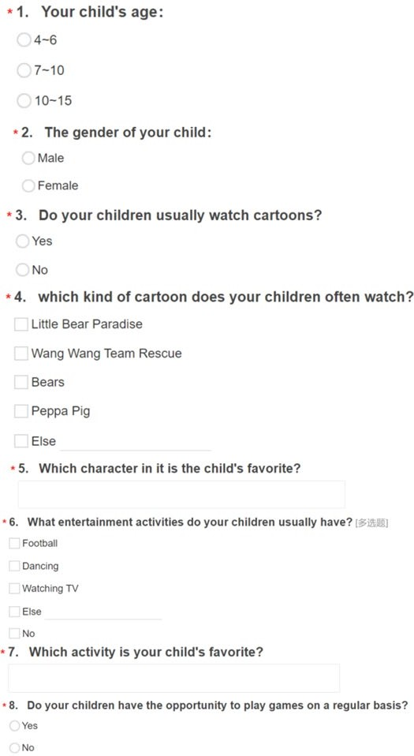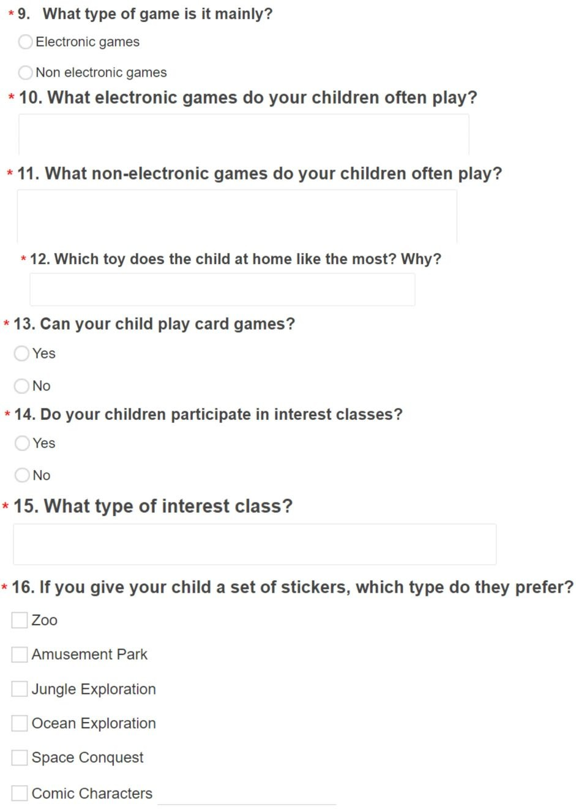

Figure 6 : Questionaire of the preliminary survey

The survey results showed that school-age children had a preference for themes or characters related to nature, animals, and the universe. Drawing was a popular recreational activity for most children. In addition, card games were too difficult for school-age children, and very few children had been exposed to such games.

Therefore, when designing the system, themes or characters related to nature, animals, and the universe should be prioritized, and drawing games should be preferred.

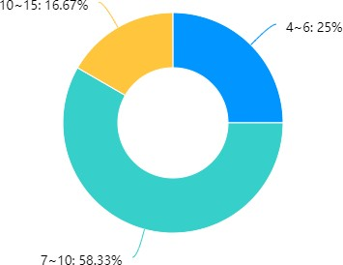

Age 10-15 : 16.67%

Age 4-6 : 25%

Age 7-10 : 58.33%

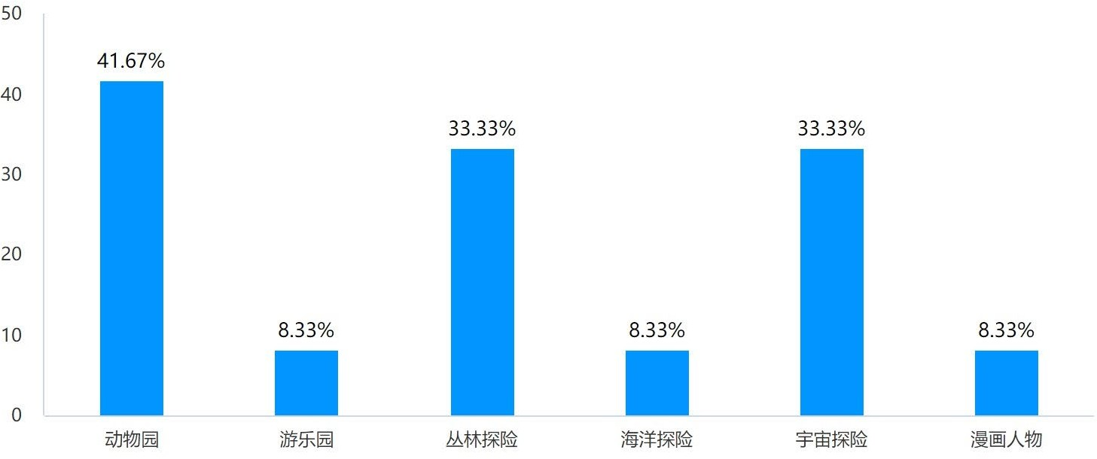

Zoo Amusement Park Jungle Exploration Ocean Excploration Space Conquest Comic Characters

* + 1. Age distribution

## Design requirements

(b) Topic preferences

Figure 7 : Survey Results

The design requirements of this study include:

1. Designing the system hardware, which utilizes microprocessors to process captured data, sensors to detect arm extension movements, and wireless communication for data recording and storage.
2. Designing games related to existing equipment to motivate patients to engage in rehabilitative exercise.
3. Enhancing the enjoyment of training through interactive forms such as visual feedback and voice instructions.
4. Improving the equipment design based on user testing.

## CHAPTER 3

**Overview of The Hardware Design**

## System Design Proposal

The system consists of a spherical rehabilitation device and an interactive computer game. The developed rehabilitation device includes an inertial measurement unit (IMU) MPU-6050, which consists of an accelerometer sensor for measuring the acceleration of wrist joint movement. The raw acceleration data from the MPU-6050 sensor is sent to the ESP32 microcontroller for processing and mapping into angle data. The processed data is then transmitted to a personal computer (PC) for operating an interactive computer game developed using Unity game development software.[9,11]

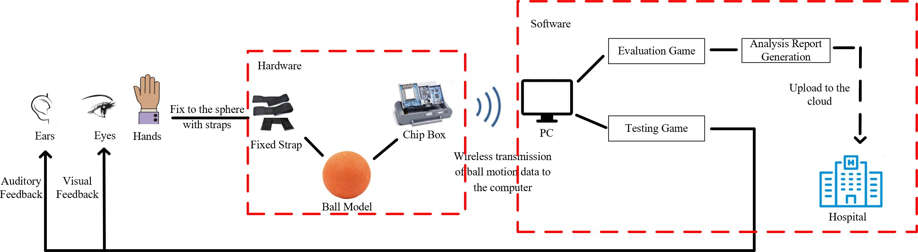

Figure 8 : Prototype system

In the planned development of the computer game, users will control the movement of the protagonist on the computer using the spherical rehabilitation device, and complete designated tasks. During the process, visual and auditory feedback will be provided to motivate users to modify their movements and perform correct rehabilitation exercises. The macro recording software on the computer can save the accurate movement of the cursor to a text file and create a demonstration video showing the movement of the cursor in the x-axis and y-axis graphical images. [12] In addition, the data recording feature of Unity can provide statistics such as average game time and number of successful completions. All these data will be summarized in a data report and uploaded to the hospital cloud storage. Therefore, therapists can analyze the rehabilitation performance based on the demonstration videos that can be shown to users, and effectively modify the exercise methods according to the users' performance and condition.

## Hardware Structure and Analysis

The hardware components of the system include a sphere, a strap, a vibrator, a chip storage layer, and a camera. The selection of these components is based on two main principles: small size and low power consumption, to meet the requirements of portability and long-term operation of the device. [13]

**Microcontroller Unit**

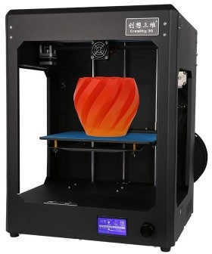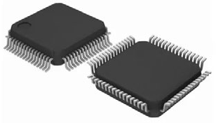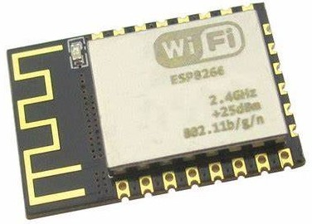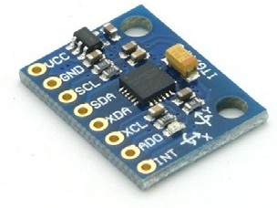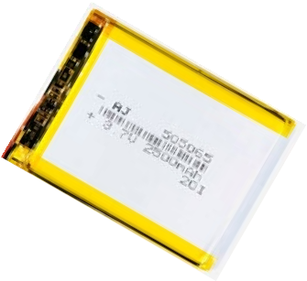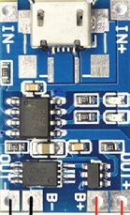

**Inertial Measuring Unit**

**Wireless Transmission Module**

**Hardware Component**

**3D Model**

**Battery**

**Charging Module**

Figure 9 : Hardware Component

The core part of the hardware is the chip storage layer, which is autonomously designed and 3D printed based on the internal component structure. It consists of an inertial measurement unit, a microcontroller, a wireless transmission module, a battery pack, and a charging module. The strap, vibrator, and chip box are all integrated into the customized sphere. The inertial measurement unit detects the movement of the arm during stretching. The microcontroller processes the data captured by the sensor. The wireless transmission module records, stores, and transmits the data.

## Component Selection

Figure 10 shows the hardware development process.

**Inertial Measuring Unit**

**Wireless Transmission Module**

**Microcontroller Unit**

**Battery**

**Charging Module**

**3D Model**

Figure 10 : Hardware development process

### Inertial Measuring Unit

An Inertial Measurement Unit (IMU) is a device that integrates multiple inertial sensors, such as accelerometers, gyroscopes, and magnetometers, for measuring and detecting the motion state and orientation of objects. It can be used to measure the attitude of an object, including pitch, yaw, and roll angles, as well as detect and measure the acceleration and angular velocity of the object, thereby estimating its motion state, such as velocity, acceleration, and angular rotation. This is crucial for navigation, attitude control, and posture stability in many applications. IMUs are widely used in various fields, including aerospace, maritime, automotive, drones, robotics, virtual reality (VR), and augmented reality (AR).

There are two main IMU options considered in this study: WHEELTEC N100 and ATK- MPU6050.

Table 1 : IMU selection

|  |  |  |  |  |
| --- | --- | --- | --- | --- |
| **Types** | **Size** | **Power** | **Advantages** | **Disadvantages** |
| WHEELTEC N100  （Nine-axis  attitude sensor） | 31mm  * 41mm | 5V | Featuring a powerful Sigma Point Kalman filter (SPKF), as well as a set of high performance algorithms, up to 1000Hz sensor sampling frequency and cone and rowing motion compensation for high accuracy, high immunity to magnetic interference and a wide range of  applications. | Higher price, slightly larger size |
| ATK- MPU6050  （Six-axis  attitude senso） | 16mm  * 18mm | 3.3V/5V | A digital motion processing (DMP) hardware acceleration engine is included to output the posture solved data to the application via the main IIC interface. Using the motion processing library provided by InvenSense, attitude resolution can be easily implemented, reducing the load of motion processing operations on the operating system and significantly reducing the development  effort. | Average precision |

The WHEELTEC N100 inertial navigation system is suitable for mobile robots, drones, lawnmowers, and other products. It consists of a three-axis gyroscope, a three-axis accelerometer, a three-axis magnetometer, and a temperature sensor, making it a nine-axis

attitude sensor series. It has strong anti-magnetic interference capability and provides high- precision position, velocity, and attitude estimation. However, the N100 is expensive, with a market price of over 200 yuan.

The MPU6050 chip from InvenSense integrates a three-axis gyroscope and a three-axis accelerometer internally, and it can output attitude-algorithm-processed data to the application end through the main IIC interface using its built-in digital motion processing hardware acceleration engine. By using the motion processing library provided by InvenSense, attitude estimation can be easily implemented, reducing the computational load on the operating system and lowering the development difficulty. Furthermore, the MPU6050 also offers price advantages, with a market price of only around 20 yuan. Therefore, the MPU6050 is chosen for the development of this system.

The physical image of MPU6050 is shown in Figure 11.

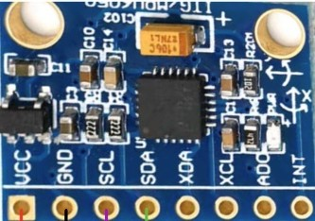

Figure 11 : MPU6050

### Microcontroller Unit

Microcontroller Unit (MCU) is a microcomputer chip that integrates functions such as a processor, memory, and peripheral interfaces. It is typically used in embedded systems for controlling and managing various devices and systems. Microcontrollers can perform tasks such as computation, control, communication, and data processing, and are characterized by small size, low power consumption, low cost, and high reliability.

Microcontrollers typically include one or more processor cores, typically 8-bit, 16-bit, or 32- bit processors, for executing various computation and control tasks. They also include a certain amount of flash or EEPROM memory for storing program code and data. Microcontrollers often provide multiple peripheral interfaces such as serial ports, parallel ports, SPI, I2C, etc., for communication and data exchange with other devices. In addition, microcontrollers typically have input/output (I/O) pins for digital signal input and output with external devices,

as well as timers and counters for implementing various timing, counting, and pulse counting functions.

There are four main main options considered in this study: Nano stm32F103、Arduino nano、Ardunio R3 and ESP32 ROOM.

Table 2 : MCU selection

|  |  |  |
| --- | --- | --- |
| **Types** | **Size** | **Characteristics** |
| Nano  stm32F103 | 100mm*60mm | Large size and comprehensive functionality |
| Arduino nano | 43mm*18mm | Smaller size and limited functional pins may not be enough |
| Ardunio R3 | 75mm*53mm | Large size and comprehensive functionality |
| ESP32 ROOM | 54.6mm*28mm | Integrated wireless transmission module |

The Nano STM32F103 is a microcontroller development board based on the STM32F103C8T6 microcontroller, which belongs to the STM32 series of microcontrollers based on ARM Cortex- M3 architecture. This development board is compact and affordable, and provides various features required for embedded system development.

Arduino Nano and Ardunio R3 development boards is similar. They both have rich hardware resources, including built-in USB interface for programming and debugging, onboard LEDs, reset button, and user button, etc. They can also be programmed and debugged using the standard Arduino IDE (Integrated Development Environment), making them convenient for developers to perform rapid prototyping and embedded system development.

The ESP32 ROOM adopts Espressif's ESP32 chip, which is a highly integrated dual-mode wireless communication chip for Wi-Fi and Bluetooth. It features a dual-core processor with a high clock frequency of up to 240 MHz, built-in 520 KB of SRAM and 4 MB of Flash memory, and supports rich digital and analog I/O interfaces, providing powerful computing and communication performance for Internet of Things (IoT) applications. In addition, the ESP32 ROOM also supports multiple communication protocols, including Wi-Fi, Bluetooth (including Classic Bluetooth and Low Energy Bluetooth or BLE), SPI, I2C, UART, PWM, ADC, etc. It also has abundant hardware resources, including multiple GPIO pins, onboard LEDs, reset button, and user button, making it convenient for developers to perform rapid prototyping and

embedded system development.

Compared to other development boards, the ESP32 ROOM has significant advantages in terms of board size, communication protocols, and memory size, etc. Therefore, the ESP32 ROOM is chosen for development in this system.

The physical image of ESP32 ROOM is shown in Figure 12.

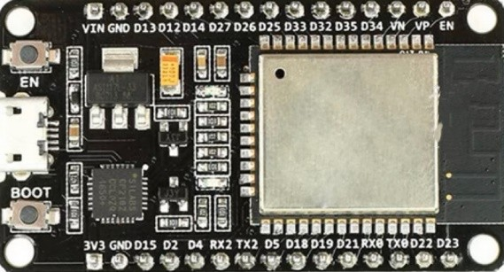

Figure 12 : ESP32 ROOM

### Wireless Transmission Module

The wireless transmission module is a widely used device in fields such as wireless communication, Internet of Things (IoT), automation control, smart home, and automotive electronics. It facilitates data or signal transmission between devices through wireless communication protocols. Typically composed of wireless transceiver chips, antennas, RF front-end, and digital processors, the wireless transmission module is capable of exchanging data with other devices using wireless communication protocols. The main performance indicators of the wireless transmission module include transmission distance, data transfer rate, frequency band and frequency range, power consumption, anti-interference performance, security, and cost, which encompasses the module's own cost as well as associated hardware and software costs.

There are two main wireless transmission module initially considered in the study: Bluetooth HC-05 and Zigbee DL-20. The main characteristics of the two types of wireless transmission module are show in Tabe 3.

The Bluetooth HC-05 serial module is based on the Bluetooth 2.0 specification, utilizes classic Bluetooth technology, supports Serial Port Profile (SPP) and transparent transmission mode, allowing wireless communication with other Bluetooth devices such as smartphones, tablets, and computers. It has wide applications in areas such as wireless control, data transmission,

Bluetooth audio streaming, smart homes, and remote controllers, indicating promising prospects.

Table 3 : Wireless Transmission Module selection

|  |  |  |
| --- | --- | --- |
| **Types** | **Size** | **Characteristics** |
| Bluetooth  HC-05 | 27*13mm | Digital transmission module with EDR Bluetooth protocol for  communication over a distance of 10m |
| Zigbee DL-20 | 16*32mm | Transmit power 4.5dBm, on-board PCB antenna, transmission  distance 250m |

On the other hand, the Zigbee DL-20 module is a wireless communication module based on Zigbee technology, designed for communication between Internet of Things (IoT) devices. The DL-20 module adopts Zigbee protocol, which belongs to the IEEE 802.15.4 wireless communication standard, featuring low power consumption, short range, and low data rate wireless communication technology. With small size and low power consumption, the DL-20 module is suitable for IoT applications with constrained resources, such as smart homes, smart grids, and industrial automation.

However, due to the introduction of ESP32 development board, which comes with built-in Wi- Fi and Bluetooth wireless communication chips, neither of these standalone wireless transmission modules was adopted.

### Power Supply

The charging module is mainly used to power the MCU and MPU, in order to facilitate the wireless operation and long-term use of the overall hardware.

Two power supply schemes were considered in total. One is the scheme combining lithium battery with charging module, and the other is the wireless charging scheme, which will be adopted as the optimized solution in the later stage. The main characters of the two power supply schemes are show in Table 4.

The power supply design scheme combining lithium battery with TP4056 charging module realizes safe and efficient lithium battery charging management through reasonable configuration of lithium battery. The TP4056 charging module utilizes a constant current and

constant voltage charging method, where the charging current and charging voltage can be adjusted through external components. The control of charging current and charging voltage is achieved through internal current control circuitry and voltage control circuitry. When the input voltage is higher than the voltage of the lithium battery, TP4056 will maintain the charging current at the set value until the lithium battery voltage reaches the charging termination voltage (usually 4.2V), and then automatically enter the float charging state to keep the lithium battery voltage near the termination voltage. When the lithium battery voltage drops to a certain level, TP4056 will start charging again, thereby realizing the charging and discharging management of the lithium battery.

Table 4 : Power Supply Schemes

|  |  |
| --- | --- |
| **Types** | **Size** |
| Lithium Battery +  Charging Module | 53mm*29mm |
| Wireless charging | Transmitter coil: 43mm outer diameter, 2.3mm thickness  Launch module: 18mm*8.5mm*15mm |

The physical image of ESP32 ROOM is shown in Figure 13.

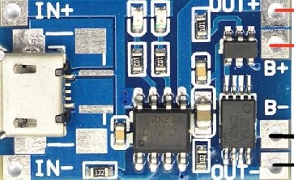

Figure 13 : TP4056 charging module

## Hardware Connection

In this hardware system design, the MPU-6050 sensor is connected to the ESP32 microcontroller using the I2C (Inter-Integrated Circuit) communication protocol. The MPU- 6050 sensor provides raw acceleration data to the ESP32 microcontroller, which then processes the data to obtain angle information.

The I2C communication protocol allows for bidirectional communication between the microcontroller and the sensor using two lines, namely the SDA (Serial Data) line and the SCL (Serial Clock) line. The SDA line is used for transmitting and receiving data, while the SCL

line is used for synchronizing the data transmission.

The microcontroller sends commands to the sensor to request data, and the sensor responds by sending the requested data back to the microcontroller. The microcontroller then processes the data according to the desired algorithm or logic, and performs necessary computations or mapping to obtain the desired output.

The specific hardware connection diagram is shown in Figure 14.

**ON/OFF**

**3.7V**

**Battery**

**TP4056**

**Switch**

|  |  |  |
| --- | --- | --- |
| **ESP32 ROOM** | **VCC** | **MPU6050** |
| **GND** |
| **SDA** |
| **SCL** |
|  |

Figure 14 : Overall hardware connection

## Modeling

The selected hardware devices need to be integrated and housed within a spherical structure, incorporating various chips, controllers, wireless sensors, and other modules. A 3D model will be created and 3D printed. Initially, two sphere model designs were proposed.

Design option one involves integrating all the hardware components into a chip box, which will be embedded on the exterior surface of the spherical model, as illustrated in the conceptual diagram in Figure 15.

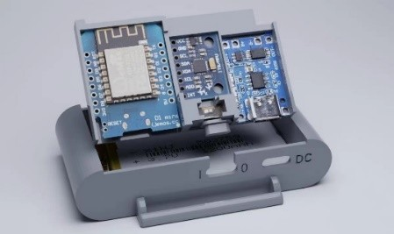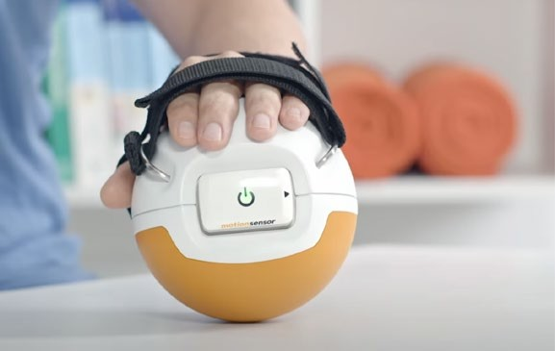

Figure 15 : Model Concept

Design option two involves integrating all the hardware components inside the sphere, rather

than on the surface. Compared to design option one, this design provides a more stable model structure and allows for larger battery capacity to meet the requirements of long-term use. However, it also requires higher 3D modeling capabilities and welding difficulty.

After considering factors such as modeling capability, welding difficulty, application prospects, and applicability, design option two was ultimately chosen as the final modeling approach.

In terms of the actual surface structure, the sphere needs to be designed to incorporate features such as fixed straps and finger grooves, in order to comply with ergonomic design principles. During the design process, research on hand dimensions of children in the school-age range is necessary. Publicly available statistical data shows that the hand diameter of children under 10 years old is approximately 5 cm. Therefore, the grooves and strap structures for hand fixation should be designed based on this measurement. After the preliminary design is completed, on- site research is required to further optimize the physical structure of the sphere.

The design of the current model underwent a total of 4 iterations (Figure 16), which will be described in detail below.

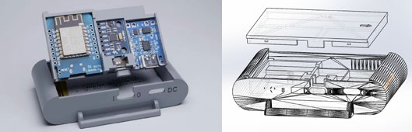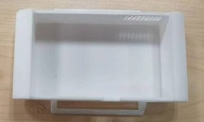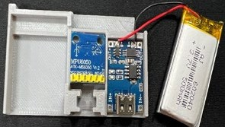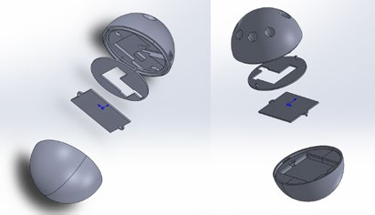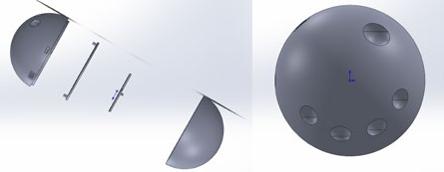

**Version 1**

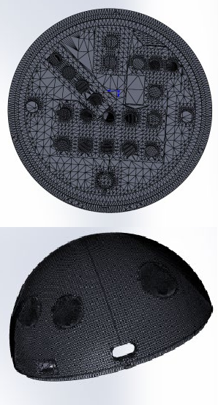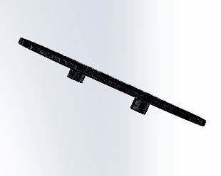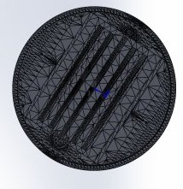

**Version 2**

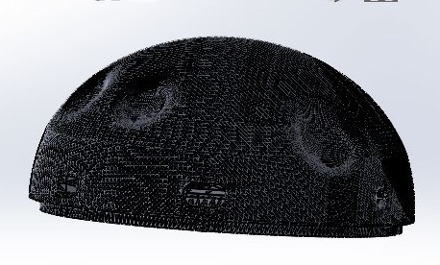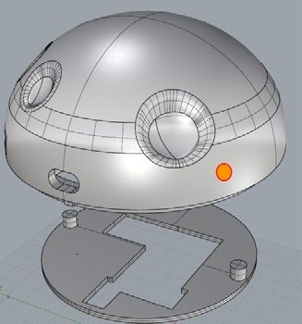

**Version 4**

Figure 16 : Model Iterations

**Version 3**

### Version 1

The initial design of the model involved embedding the chip box on the surface of the sphere. The bottom layer is the battery layer, which is used to store lithium batteries. The second layer is the chip layer, where MCU, sensor and charging module will be integrated. On the shell, we designed the top cover, heat sink and type-C charging socket.

However, it was later realized that the size of the battery box could not meet the long-term power capacity requirements of the system. Therefore, the decision was made to integrate the entire hardware circuitry inside the sphere.

### Version 2

The second version of the model divides the entire sphere into two parts, the upper and lower hemispheres. The upper hemisphere contains all the core control units, such as MCU, IMU, and charging module, which are cleverly fixed in place with designed slots and covers to prevent displacement and loosening. The lower hemisphere is used to hold a 2500mAh battery, which is secured with a cover. There are two openings on the surface of the sphere, one for installing a switch and the other for charging.

After practical testing, the second version of the model was found to have issues such as the inability to insert a Type-C charging cable into the sphere for charging, the loosening and easy breakage of the fixing slots for the two hemispheres, and the lack of heat dissipation openings. As a result, the model underwent further iterations, and the third version was optimized to address these issues.

### Version 3

The third version of the model, based on the second version, adds a heat dissipation module, enlarges the charging port, and thickens the cylindrical slots used for fixing.

The third version of the model was used in actual tests and surveys with pediatric patients. Feedback from the subjects revealed that the finger grooves on the model did not match the human hand structure, the edges of the finger grooves were not smooth enough, and the surface

curvature of the upper hemisphere was too large for comfortable placement on the palm. As a result, further modifications were made to the model.

### Version 4

The fourth version of the model includes optimized finger groove positions, reduced surface curvature at the palm area, strap fixing slots, and further optimized charging port.

In addition, the overall weight of the hardware system, including the sphere and the circuitry, was 218.4kg, and the volume of the sphere was 10cm in diameter, which met the portability requirements of the design objectives. The physical model of the final version is shown in Figure 17.

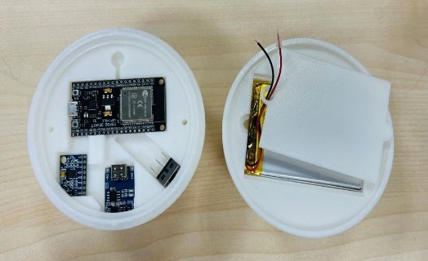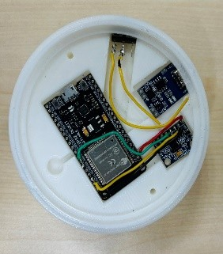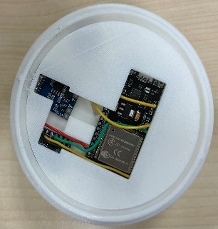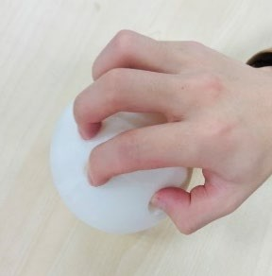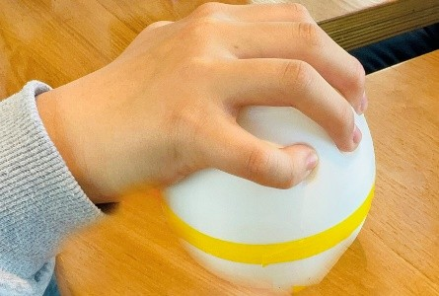

Figure 17 : Physical model of the final version

## CHAPTER 4

**Overview of The Software Design**

## Overall Software Design

The software part could be concluded as Figure 18. The software design of this system consists of two functional parts: the game and the data analysis storage. From the adopted technical means, it can be divided into three categories: embedded software design, game design, and Internet of Things (IoT) design.

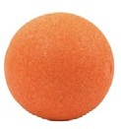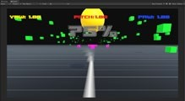

**User changes action**

**Ears Eyes**

**Data Receive**

**Ball Data**

**Game running**

**Action Guidance**

**Upload to cloud**

**Rehabilitation report**

**Data Analysis**

Figure 18 : Software Structure

Embedded software design will be based on the ESP32 development board, combined with the VScode editor and PlatformIO environment for compilation, to collect, process, and send the data generated during device usage.

Game design includes creating game mechanics, levels, characters, and assets, as well as testing and refining the game to ensure it is engaging and enjoyable for users. It will use Unity software based on the C# language for development, using interesting and innovative games to attract pediatric patients for rehabilitation training, which can be divided into exercise games and assessment games.

IoT design will be based on the Alibaba Cloud platform, used for storing and processing motion data generated during the game process.

The flowchat of the whole software is as follows:

**Inertial Measuring Unit**

**Bluetooth Module**

**Unity**

**Alibaba Cloud**

I2C

**Bluetooth 4.0**

**MQTT**

**Microcontroller Unit**

Figure 19 : Software Structure

## Data Collection Based on ESP32

ESP32 can communicate with MPU6050 through the I2C interface to collect and process data from MPU6050. The program design flowchart for collecting MPU6050 data using ESP32 is as follows:

**Configure the system**

**clock source, enable gyroscopes and acceleration sensors**

**Print sensor data to serial port for verification**

**Initialize IIC**

**Reset MPU6050**

**Set parameters for gyroscope and acceleration sensor**

**Set interrupt, sampling rate, digital filter**

Figure 20 : Flowchat of Data Collection Based on ESP32

After initializing ESP32 and MPU6050, we need to configure MPU605, setting its operating mode, measurement range, filters, etc. Configure according to actual needs, such as selecting the measurement range of the accelerometer and gyroscope, setting the sampling rate, and low- pass filter frequency, etc.

### Gyroscope configuration

Table 5 : Gyroscope configuration register



FS_SEL[1:0] is used to set the full-scale range of the gyroscope. In this project, it is set to 3,

which corresponds to

2000o /S . As the gyroscope's ADC has a resolution of 16 bits, the

sensitivity is

65536 / 4000  16.4LSB/(o /S) .

### Accelerometer configuration

Table 6 : Accelerometer configuration register



AFS_SEL[1:0] is used to set the full-scale range of the accelerometer. In this project, it is set to 0, which corresponds to 2g. As the accelerometer's ADC is also 16 bits, the sensitivity is 65536 / 4  16384LSB/g .

### Sampling rate

Table 7 : Gyroscope sampling rate divider register



The gyroscope sampling rate divider register is used to set the gyroscope sampling frequency of the MPU6050, and the calculation formula is:

*fsample* 

*fout* / (1 *SMPLRT* _ *DIV* )

(1)

Here, the output frequency of the gyroscope is either 1 or 8kHz, depending on the setting of the digital low-pass filter (DLPF). When DLPF_CFG=0/7, the frequency is 8kHz, and in other cases, it is 1kHz. Moreover, the DLPF filter frequency is generally set to half of the sampling rate. If the sampling rate of this system is set to 50Hz, then SMPLRT_DIV=1000/50-1=19.

### Process raw data

The data from the MPU6050 is represented in raw binary form and needs to be parsed and converted to obtain actual acceleration and angular velocity values, such as unit conversion, filtering, attitude calculation, etc. Data processing algorithms, such as Kalman filtering and complementary filtering, can be designed according to the requirements of the actual application to improve the accuracy and stability of the data.

The MPU6050 has a built-in Digital Motion Processor (DMP), and InvenSense provides an embedded motion driver library for the MPU6050. By combining the DMP of the MPU6050, the raw data can be directly converted into quaternion output, and after obtaining the quaternion, it is easy to calculate Euler angles, thereby obtaining yaw, roll, and pitch.

The formulas for calculating quaternions and yaw angles are as follows:

*pitch*  arcsin(2(*q*0 •*q*2  *q*1 •*q*3 ))

(2)

*roll*  arctan(

2(*q*0 •*q*1  *q*2 •*q*3 ) )

*q* 2  *q* 2  *q* 2  *q* 2

0 1 2 3

(3)

*yaw*  arctan(

2(*q*0 •*q*3  *q*1 •*q*2 ) )

*q* 2  *q* 2  *q* 2  *q* 2

0 1 2 3

(4)

Where the unit quaternion

*q* , *q* , *q* , *q* satisfies the condition: *q* 2  *q* 2  *q* 2  *q* 2  1 .

0 1 2 3 0 1 2 3

Using the built-in DMP greatly simplifies the code design for attitude estimation, and the MCU does not need to perform attitude calculation, which reduces the burden on the MCU and provides more time to handle other events, improving system real-time performance.

## Communication between microcontroller and PC

The communication between the microcontroller and PC is achieved by using the integrated Bluetooth module of ESP32, which supports two types of Bluetooth protocols: Classic Bluetooth and Bluetooth Low Energy (BLE).

In the actual design process, the power consumption of the device was considered as a priority, and thus Bluetooth Low Energy (BLE) was initially chosen for communication. However, it was later discovered that BLE had compatibility issues, as the data transmitted via BLE could not be mapped to the virtual serial port on the PC, and therefore could not be retrieved and utilized by Unity software. As a result, a trade-off was made in terms of power consumption, and Classic Bluetooth was ultimately used for data transmission and communication.

Input ESP32 BlueTooth Library

Set Bluetooth Service and Characters

Define Data Type

Figure 21 : Flowchat of BlueTooth Usage

## Game Design and Implementation Based on Unity Platform

Unity3D is a cross-platform game engine and development environment developed and released by Unity Technologies. It is widely used in various fields such as games, virtual reality (VR), augmented reality (AR), simulators, and interactive applications. Unity3D supports multiple platforms, including Windows, macOS, Linux, iOS, Android, WebGL, PlayStation, Xbox, etc., allowing developers to build and publish projects to different platforms simultaneously. Unity3D uses C# as the primary scripting language, providing rich APIs and tools for developers to write custom game logic, interaction behaviors, game rules, etc.

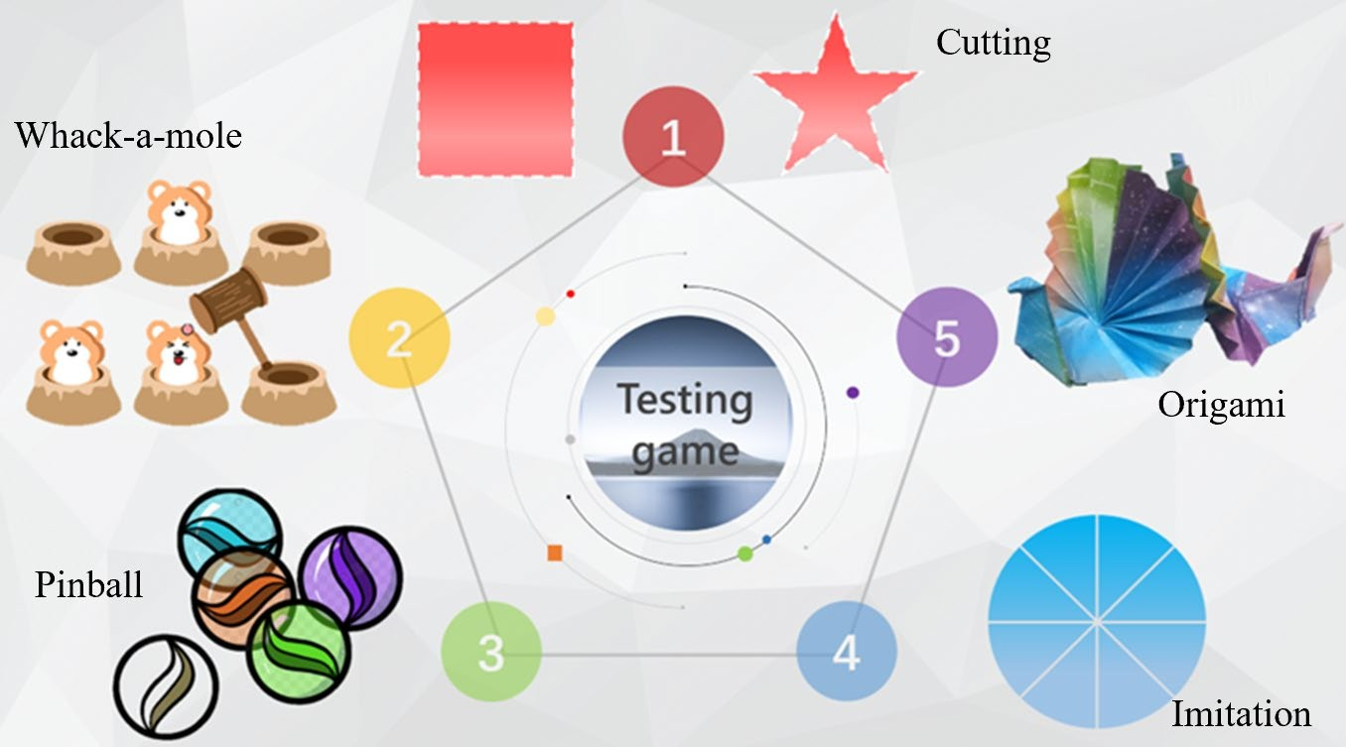The game design is divided into training and testing designs. The training design uses fun games combined with visual cues (RGB color cues) and auditory cues (different sound effects for correct and incorrect actions) to guide pediatric patients in performing movements and enhance their motivation. The testing part involves designing five games(Figure 22): cutting, whack-a- mole, pinball, imitation, and origami, to assess the patients' movement speed, accuracy, range of motion, duration of activity, and reaction time.

Figure 22 : Game concept

For testing games, we give priority to designing drawing games and bring them to hospitals for children to use. If the feedback is highly positive, we will continue to create the remaining test games.

This part includes creating game mechanics, levels, characters, and assets, as well as testing the game to ensure it is engaging and enjoyable for users. The software design process can concluded as Figure 23:

Art design

Sound Design

Level Design

Figure 23 : Game design process

## Data Processing Based on Cloud Platform

The motion data generated by pediatric patients while using the device, such as range of motion, velocity, accuracy, rotation angle, duration of activity, and reaction time, will be acquired, processed, and exported by ESP32. The integrated wireless transmission module of ESP32 will be utilized to wirelessly send these motion data through Wi-Fi, which will then be stored on the Alibaba Cloud platform for visualization processing, generating health assessment reports, and assisting healthcare professionals in treatment.

Alibaba Cloud offers a rich array of cloud computing products and services, including computing, storage, databases, networking, security, artificial intelligence, big data, IoT, and more. This system mainly utilizes the cloud services and IoT functionality provided by Alibaba Cloud. Elastic Compute Service (ECS) offers flexible virtual servers that allow users to create and manage virtual machines according to their needs, supporting deployment of various operating systems and applications. Meanwhile, IoT service provides a series of IoT services such as device management, data collection, and data processing for building intelligent IoT applications. ESP32 uses MQTT protocol to connect to Alibaba Cloud IoT platform via Wi-Fi.

MQTT (Message Queuing Telemetry Transport) is a lightweight, publish-subscribe, messaging protocol that is widely used for communication between devices in Internet of Things (IoT) and other low-bandwidth, high-latency, or unreliable network environments. MQTT follows a client-server architecture, where MQTT clients, also known as MQTT nodes, connect to an MQTT broker, which acts as a message broker or intermediary. The MQTT broker is responsible for receiving messages from MQTT clients and delivering them to the intended recipients, known as MQTT subscribers. MQTT clients can also publish messages to MQTT topics, which are string-based identifiers that categorize messages into different channels or subjects.

The software design process is shown in Figure 24:

Creating products and devices on Alibaba Cloud

Obtain Alibaba Cloud platform device certificate

Introducing the MQTT protocol and modifying parameters

Configure cloud platform model data

Set the function for reporting parameters to the cloud platform

Turn on and set Wi-Fi parameters

Figure 24 : Cloud platform connection process

For this project, the Alibaba Cloud platform device certificate is as Figure 25 shows. These certificates need to be included in the MQTT protocol.



Set MQTT check and reconnect functions

Set MQTT

connection and disconnect event callback functions

Figure 25 : Alibaba Cloud platform device certificate

## CHAPTER 5

**Testing**

## Device Function Test

### Hardware part

First, I will test the logical functionality of the hardware device and check if the device is working properly. The testing method is as follows:

* After the device is powered on, the Bluetooth signal of the device can be detected by the computer. After connecting via Bluetooth, real-time device location data can be obtained using a Bluetooth serial assistant on the computer.
* Insert a Type-C charging cable into the charging port of the device and check if the device can charge properly, indicated by a red LED.
* Open the Alibaba Cloud platform to check if the platform can detect the device and store data correctly.

Testing photos are shown below:

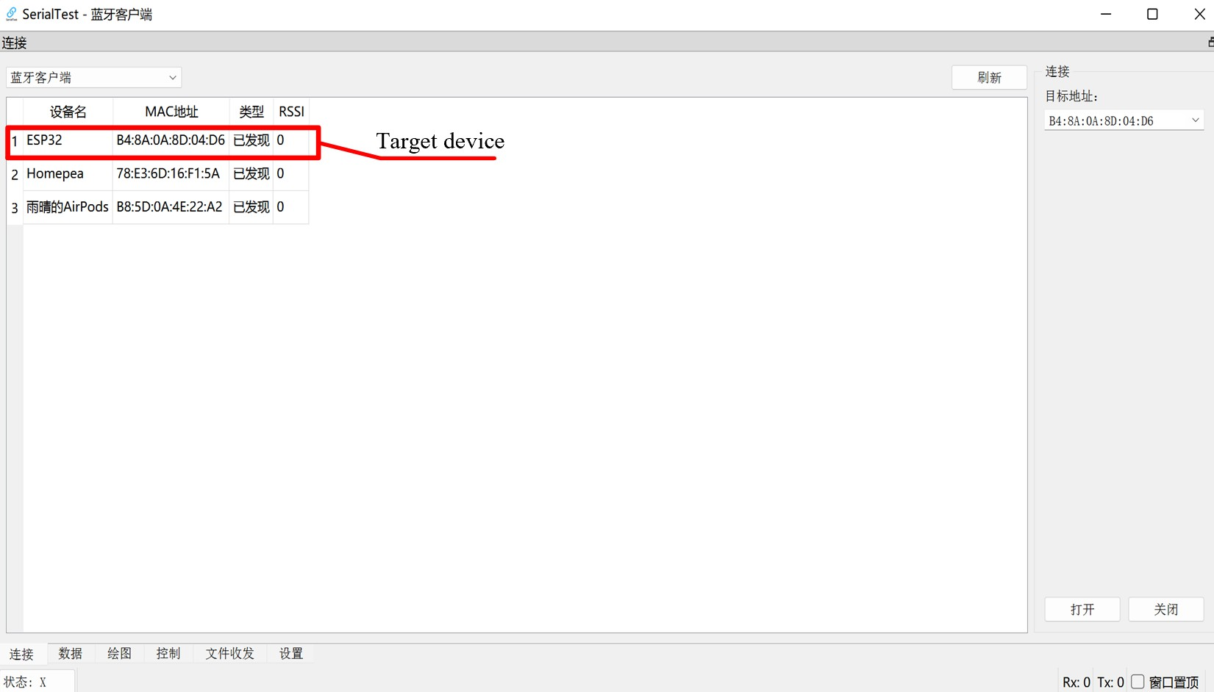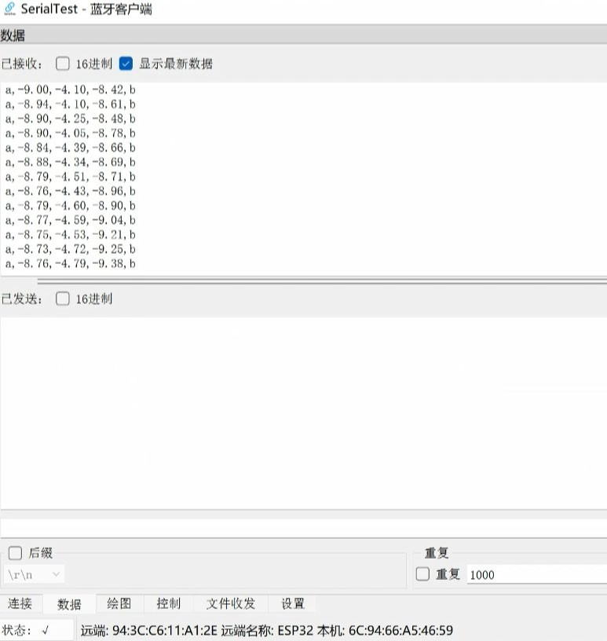

Figure 26 : Bluetooth connection



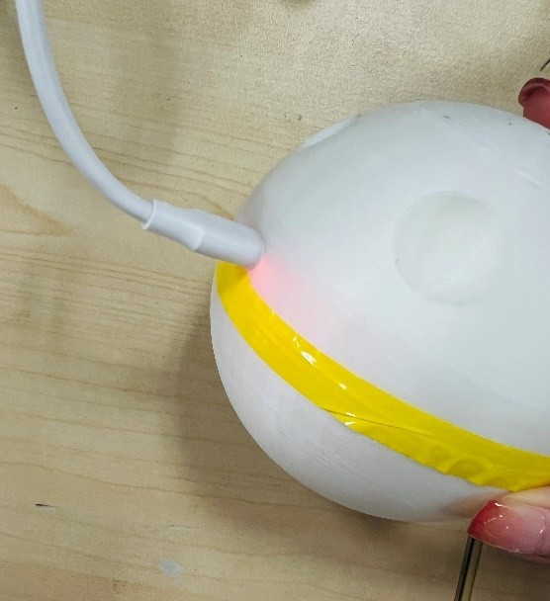

Figure 27 : Charging port

**Device connected Device launch time**

Figure 28 : Alibaba Cloud platform connection

### Software part

In this part, I will test the connection between the hardware device and the Unity. The testing method is as follows:

* Open the published game and check if it correctly opens the serial port.
* Check if Unity can accurately read the device's location data and reflect it in the game.

Testing screenshots are shown in Figure 29:

Here, c1 refers to the difference between the initial yaw and the latest yaw, while c2 refers to the difference between the initial pitch and the latest pitch.

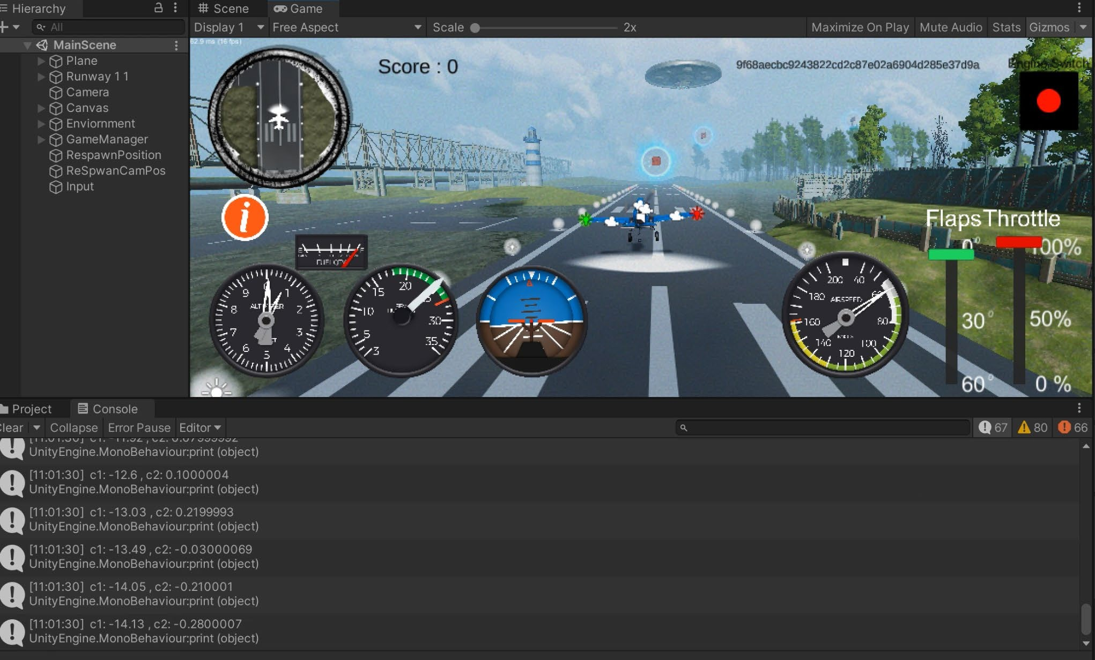

**Received Data**

Figure 29 : Unity connection and control

## Main Problems and Solutions

During the debugging process, there were also many issues, some related to hardware and some related to software. Here, we explain the main problems encountered and their solutions as shown below.

## Problem Description: Unity cannot use data transmitted via Bluetooth Low Energy (BLE) for PC game development.

* **Root Cause:** BLE is a relatively new Bluetooth communication protocol with less device compatibility compared to Classic Bluetooth.
* **Resolution:** Switch to Classic Bluetooth for data transmission, or try using third- party plugins or libraries to address BLE compatibility issues.

1. **Problem Description:**When enabling both Bluetooth and Wi-Fi functions on ESP board simultaneously, the program exceeds the Flash storage space of the development board, resulting in compilation errors.

* **Root Cause:** ESP32 has a total of 4MB Flash storage, which should be sufficient

in theory. However, due to the partition table used by ESP32 to allocate different types of content in the storage, the Flash storage space may run out.

* **Resolution:** Modify the partition table of ESP32 and invoke it in the initialization configuration of PlatformIO to expand the program storage space, or simplify the code to reduce storage space usage.

1. **Problem Description:** ESP fails to work properly when powered by a lithium battery combined with a charging module.

* **Root Cause:**The voltage of a lithium battery can reach 4.2V, which exceeds the voltage threshold of ESP pins (3.3V).
* **Resolution:** Connect the power line from the 3.3V pin of ESP to the 5V pin, or use voltage regulators or other voltage regulators to stabilize the output voltage of the lithium battery at 3.3V for powering ESP.

1. **Problem Description:**The smoothness of control is reduced when the circuit is placed inside a sphere.

* **Root Cause:** The MPU6050 deviates from the ideal orientation when placed inside a sphere, causing the original control program to be unusable.
* **Resolution:** Adjust the sphere model to make the MPU6050 position as standard as possible, and adjust the control program accordingly. Calibration may also be needed based on actual conditions, or consider using sensors more suitable for the internal environment of the sphere.

## CHAPTER 6

**Results**

### The hardware component is able to detect different arm movements and reflect them in the games.

This system involves two different games, one involving flying an airplane and the other involving drawing. Both games are controlled using the hardware ball model from this system, which is connected to the games via Classic Bluetooth in Unity.

In the airplane flying game, different arm movements correspond to different flight states of the airplane. As shown in the diagram, when the hand is raised, the airplane will ascend; when the arm is extended forward, the airplane will dive; when the arm rotates to the left, the airplane will turn left; and when the arm rotates to the right, the airplane will turn right.

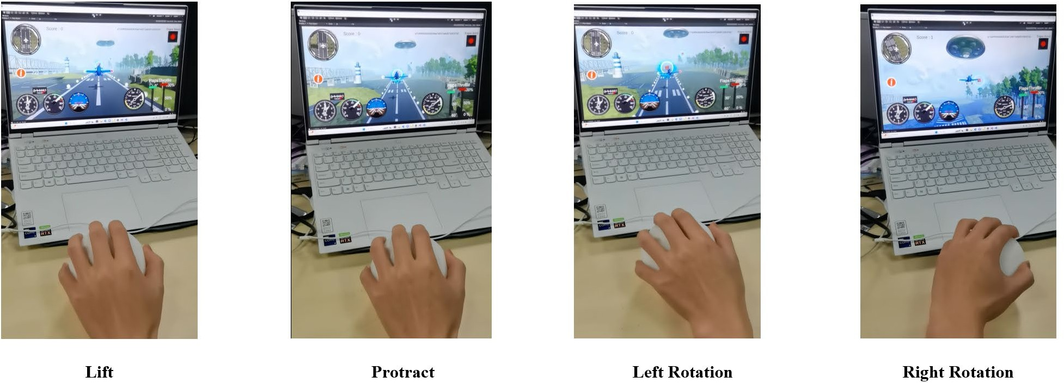

Figure 30 : Airplane flying game

In the drawing game, different arm movements correspond to the direction of the brush in the drawing game. As shown in the diagram, when the hand is raised, the brush will move upward; when the arm is extended forward, the brush will move downward; when the arm rotates to the left, the brush will move to the left; and when the arm rotates to the right, the brush will move to the right.

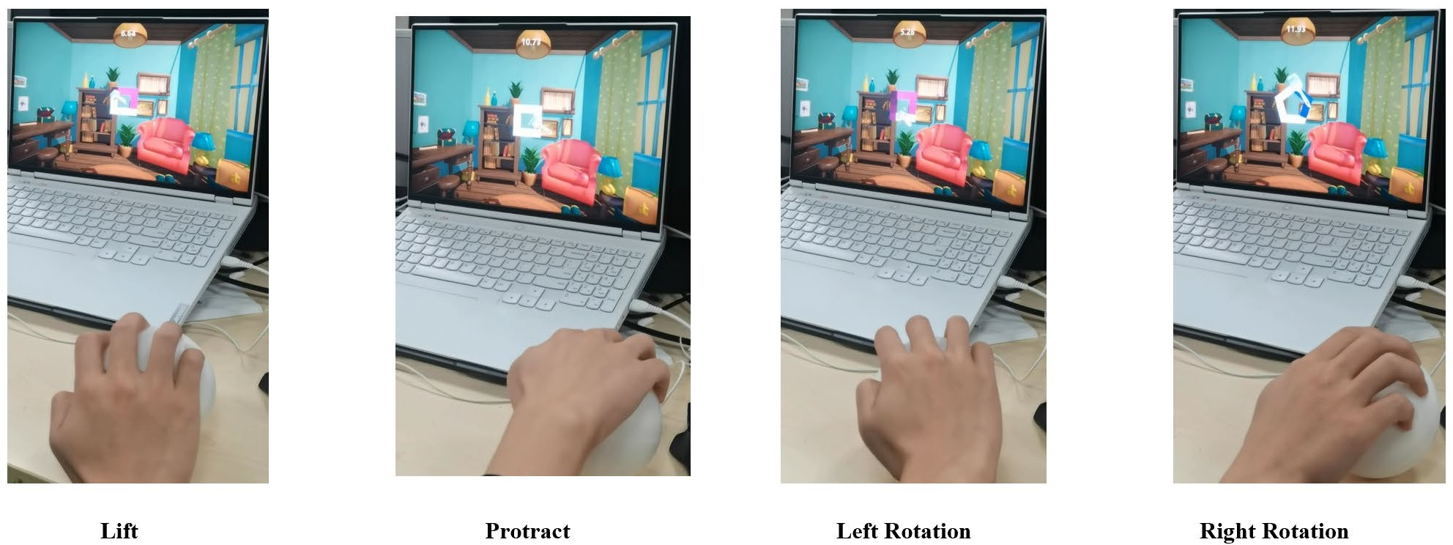

Figure 31 : Drawing game

### The system is able to record and store data on Cloud

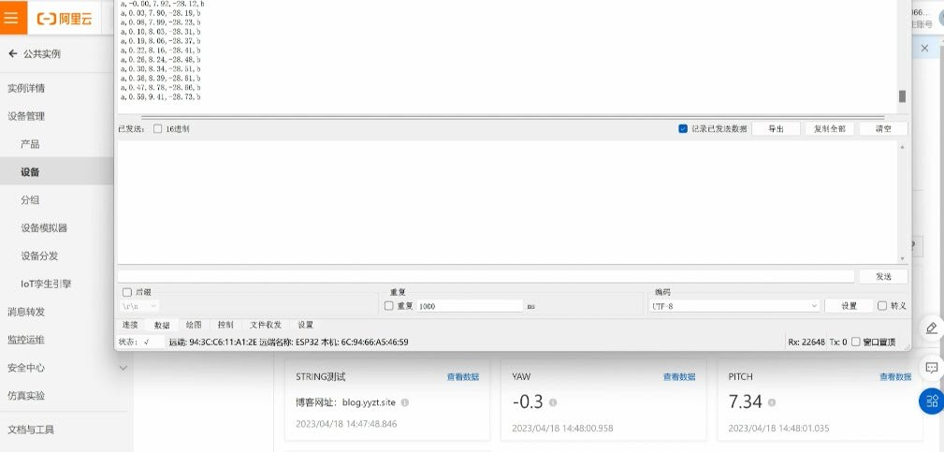Using the Wi-Fi module of ESP32 and the MQTT Internet of Things (IoT) protocol, the cloud- based recording and storage of motion data is achieved. Figure 32 shows the transmission of motion data and the data recording function on the Alibaba Cloud platform. The data recording function on the Alibaba Cloud platform does not provide real-time updating and display like a serial port. Through practical testing, a data upload interval of 500ms has been found to provide a stable transmission rate (Figure 33).

Figure 32 : Transmission and recording function on Cloud platform

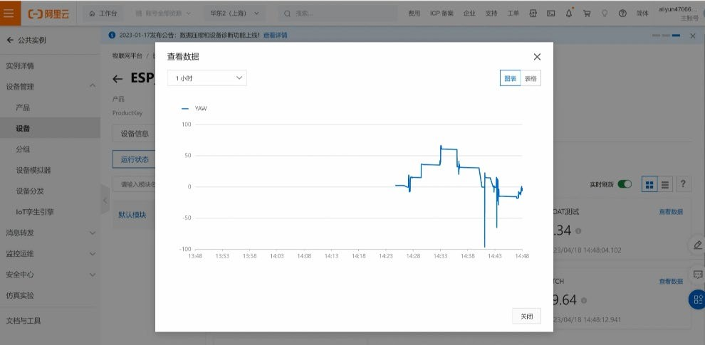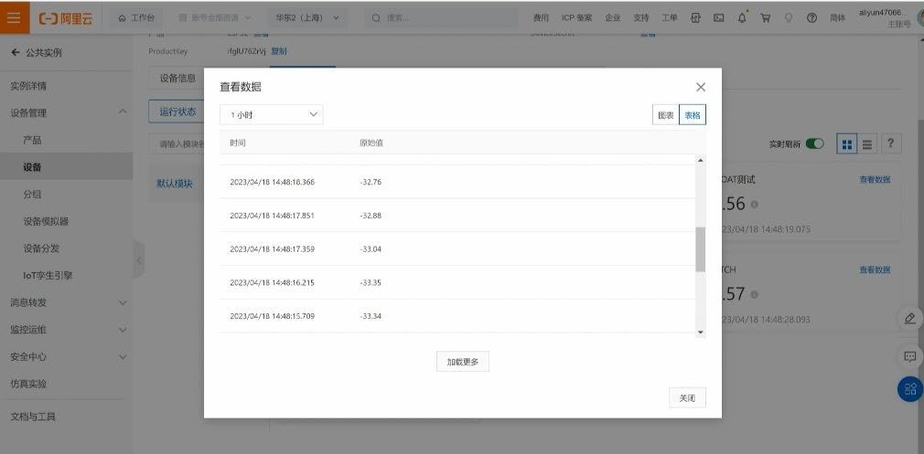

Figure 33 : Date record and update

## CHAPTER 7

**Conclusion and Future Work**

## User Feedback

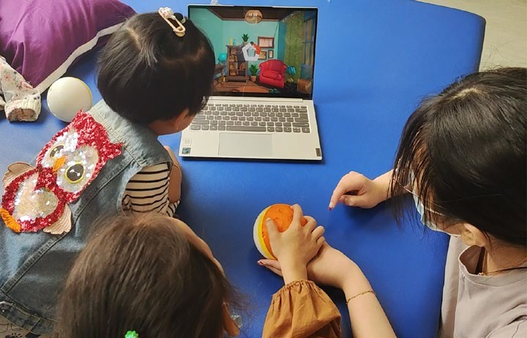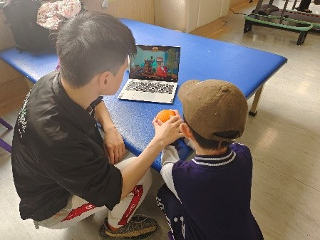After a complete design and implementation, we conducted a user survey involving 3 children under 10 years old, 3 caregivers of pediatric patients, and 1 doctor. The majority of the respondents expressed satisfaction with the device, stating that it could attract children's attention and that the game interface was helpful for the cognitive abilities of pediatric patients. However, some issues were also pointed out, including the relatively large size of the device, slightly complex game logic, and the requirement of certain cognitive abilities for pediatric patients. Children around 4 years old had difficulty understanding and using the device, but children around 7 years old were able to quickly learn and understand the game logic. The doctor expressed that if the device could be put into practical use, it has great potential, and provided many useful suggestions, such as simplifying game settings, allowing multiple children to play together, adding game contexts and story guidance, and enriching game types and voice feedback.

Figure 34 : The second hospital visit

## Conclusion

This paper mainly introduced the design and implementation of an interactive upper limb training device for arm stretching and extension movements. Using the ESP32 development board as the control core, upper limb motion data obtained from the MPU6050 sensor was processed and analyzed. The motion data was then sent to the computer through Bluetooth and mapped to two games, a driving airplane game and a drawing game, both developed on the Unity platform. The audiovisual effects in the games could effectively attract the attention of

school-age pediatric patients, providing them with a sense of enjoyment and positive feedback during the game, motivating them to engage in continuous and active rehabilitation exercises. In addition, the device could record, store, and analyze the rehabilitation data of pediatric patients through the cloud server of the Alibaba Cloud Internet of Things (IoT) platform, facilitating subsequent rehabilitation treatment evaluations and providing assistance to doctors in updating treatment plans in a timely manner.

## Future Work

The device has great development prospects. In terms of hardware, based on the results of the last user survey, we found that the size of the device is still too large for patients with hand movement disorders. Therefore, in the future modeling, it would be better to design surface grooves that allow children to hold the device with both hands. In terms of software, first, the control logic for software-hardware interaction needs further optimization. Second, the expandability of the games needs to be improved. If more types of games similar to the existing ones can be developed, it may cater to the interests of children of different age groups. Additionally, it would be ideal if these games could support multiplayer mode[14], adding competitive elements to rehabilitation training, so that pediatric patients do not feel tired or bored due to repetitive games.

In addition, our project has entered the final round of the Yangtze River Delta Innovation Cup competition, and we hope to achieve good results in this competition. We also plan to apply for some patents for this project.

## Personal Contribution

In this project, the main responsibilities of the author included conducting user surveys, selecting hardware devices, testing, soldering, 3D modeling and printing, debugging wireless communication and interactive control between hardware devices and computer terminals, as well as implementing wireless storage of motion data on the Alibaba Cloud platform.

# REFERENCES

* + 1. Durkin M S, Benedict R E, Christensen D, et al. Prevalence of cerebral palsy among 8‐year‐old children in 2010 and preliminary evidence of trends in its relationship to low birthweight[J]. Paediatric and perinatal epidemiology, 2016, 30(5): 496-510.
    2. Johnson C O, Nguyen M, Roth G A, et al. Global, regional, and national burden of stroke, 1990–2016: a systematic analysis for the Global Burden of Disease Study 2016[J]. The Lancet Neurology, 2019, 18(5): 439-458.
    3. 弗 若 斯 特 沙 利 文 . 康 复 医 疗 器 械 市 场 研 究 报 告 [R]. [http://legacy.frostchina.com/?p=17595:弗若斯特沙利文,](http://legacy.frostchina.com/?p=17595%3A弗若斯特沙利文) 2022年6月25 日.
    4. Pilatásig M, Tigse J, Chuquitarco A, et al. Interactive system for hands and wrist rehabilitation[C]//Proceedings of the International Conference on Information Technology & Systems (ICITS 2018). Springer International Publishing, 2018: 593-601.
    5. Novak I, Morgan C, Fahey M, et al. State of the evidence traffic lights 2019: systematic review of interventions for preventing and treating children with cerebral palsy[J]. Current neurology and neuroscience reports, 2020, 20: 1- 21.
    6. Babaiasl M, Mahdioun S H, Jaryani P, et al. A review of technological and clinical aspects of robot-aided rehabilitation of upper-extremity after stroke[J]. Disability and Rehabilitation: Assistive Technology, 2016, 11(4): 263-280.
    7. Lo A C, Guarino P D, Richards L G, et al. Robot-assisted therapy for long- term upper-limb impairment after stroke[J]. New England Journal of Medicine, 2010, 362(19): 1772-1783.
    8. Nordin N, Xie S Q, Wünsche B. Assessment of movement quality in robot- assisted upper limb rehabilitation after stroke: a review[J]. Journal of neuroengineering and rehabilitation, 2014, 11(1): 1-23.
    9. Ambar R, Zakaria M F, Ahmad M S, et al. Development of a home-based wrist rehabilitation system[J]. International Journal of Electrical and Computer Engineering (IJECE), 2017, 7(6): 3153-3163.
    10. Jakob I, Kollreider A, Germanotta M, et al. Robotic and sensor technology for upper limb rehabilitation[J]. PM&R, 2018, 10(9): S189-S197.
    11. Ortiz-Sierra D A, Luengas-Contreras L A. Rehabilitation systems for the wrist: a review focused on ulna-radius articulation trauma[J]. Visión electrónica, 2019, 2(2): 409-423.
    12. Liang J, Fuhry D, Maung D, et al. Data analytics framework for a game- based rehabilitation system[C]//Proceedings of the 6th International Conference on Digital Health Conference. 2016: 67-76.
    13. Yoon H U, Anil Kumar N, Hur P. Synergistic effects on the elderly people's motor control by wearable skin-stretch device combined with haptic joystick[J]. Frontiers in neurorobotics, 2017, 11: 31.
    14. Mudie M H, Matyas T A. Upper extremity retraining following stroke: effects of bilateral practice[J]. Journal of neurologic rehabilitation, 1996, 10(3): 167-184.